“Sensory”
“Sensory” is the science of measurement with the human senses. Panelists measure subjective and individually to produce an only one objective final result. Mention of the human senses normally brings to mind the usual 5 senses, smell, taste, vision, hearing and touch. In both the sensory and the physiological sense we better speak of the modalities sense of smell, sense of taste, sense of seeing, sense of hearing and sense of touch (tactile or haptic sense). These modalities include other senses which are also very important for Sensory, such as sense of temperature and sense of pain. All these senses resp. modalities are important for quality testing of flavourings. Before we give a brief outline of them, various terms need to be defined, i.e.
Organoleptic: Relating to an attribute or a property of a sample perceived by the sense organs. A degustation is an action of gustation organoleptically. (In sensory nowadays ‘organoleptic’ is normally an obsolete term because of confusion with sensory)
Sensory: Relating to the use of sense organs. Within the meaning of ‘Sensory’ sensory in combination with other attributes additionally means performing actions with sensory panels. Therefore Sensory Testing means testing with a sensory panel.
Organoleptic Quality Control (OQC) / Organoleptic Quality Testing (OQT) Quality testing normally is an organoleptic procedure as only certain characteristics of recurring products are being ascertained. Although the testers are examined by an initial sensory selection and also receive a period of training, subsequently they are normally not subject to sensory control and sensory monitoring in regular intervals. They automatically train themselves in their own domain (see also further below).
Sensory Quality Control (SQC) / Sensory Quality Testing (SQT) SQC is carried out by sensory assessors (panelists). In this case, the characteristics (mostly of the whole product) are measured with sensory test methods in order to provide a solution to a given problem. Sensory panelists are selected, trained and monitored in regular intervals. Their qualification and performance are documented completely.
Aroma: Aroma is defined as ‘the overall impression obtained from smell and taste perceived retronasal when tasting’ (see below).
Flavour: Flavour is made up of the aroma and trigeminal perceptions when tasting (such as haptic aspects and/or hotness, strong spiciness as an aspect of the sense of pain).
The Senses
Sense of Smell
As far as olfaction is concerned, it is essential for the purposes of quality testing that a strict distinction is made between two types of smelling: – Nasal Smelling Nasal smelling is normal smelling through the nose. The active substances producing the smell pass through the nostrils on their way to the olfactory epithelium in the roof of the nasal cavity and from there through the nasopharynx to the oral / pulmonary cavity from where they are then exhaled. The process corresponds to breathing with the mouth closed. The olfactory perception can be reinforced by sniffing i.e. by swirling the air intermittently over the ethmoid bone below the olfactory epithelium. The swirling effect causes the active components producing the smell to flow past the olfactory epithelium several times (instead of just once), thereby reinforcing the effect (particularly important in quality testing in the case of weak samples or samples with only very minor differences between them).
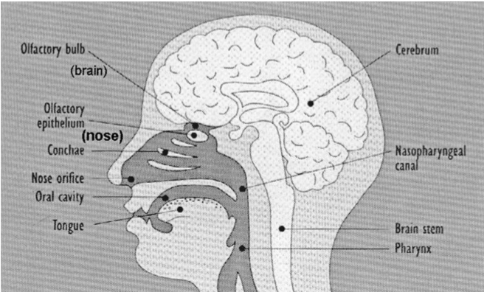
Fig.: Nasal and retronasal smelling
– Retronasal Smelling Retronasal smelling occurs when an aromatic product is placed in the mouth, the mouth is then closed and the product is “eaten”, causing the active components producing the smell to rise through he nasopharynx to the olfactory epithelium (this can be demonstrated quite simply by holding the nose closed, thus creating a counterpressure which prevents the active components from rising from the mouth to the nose). This effect can also be reinforced by smacking one’s lips or slurping. This causes additional air to be sucked into the mouth, so that the active parts of the substances producing the smell are carried and swirled past and “round the back of” (= retro) the ethmoid bone.
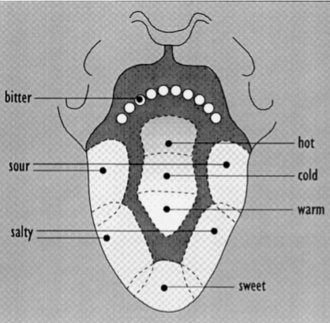
Fig.: Primary tastes on the tongue
Sense of Taste Apart from the five normal basic tastes – sweet, sour, salty, bitter and umami– a great many other actions occur in the mouth, although their importance here is limited. The basic taste sensations are experienced in different areas of the tongue. For example, sweetness is tasted more at the tip of the tongue, sour sensation move on the sides towards the back of the tongue and saltiness on both sides towards the front (Fig. 6.2). Bitter sensations are perceived predominantly towards the back of the tongue, although the precise location varies between individuals, in some cases almost as far back as the throat. This is why it is often difficult to ascertain bitterness. It is best to lick a small sample, so that if possible more papillae are reached. It is also often difficult because there are several “types” of bitterness. Saltiness is quite different, the only salty taste being that of common salt (sodium chloride). Umami (glutamate, ribotides, etc.) is perceived in the mouth to be „harmonized“.
Smell and Taste is “Aroma” or
‘Why an aroma has to be tested ‘through’ the mouth and not only ‘through’ the nose!’ Quality testing of “aromas” is often only done by smell (olfaction) alone, i.e. through the nose. This is a serious error. Because it can be seen clearly from the above that an “aroma” needs to be taken into the mouth, simply because of the different, retronasal olfactory effect. For example, the different temperature in the mouth means that the active components producing the smell are carried past the olfactory epithelium retronasally and therefore differently.
Sense of Seeing
Colour is vitally important as a part of vision (in sensory terms: the colour component of the characteristic vision). There are physiological as well as psychological reasons for this. But it would be too complicated to embark on an explanation here. At all events, it is permissible to allow colour to be an influence when an aroma is being tested, unless the colour itself is being tested. Often natural products in particular are subject to colour fluctuations, which are not necessarily related to taste.
Sense of Hearing
Sense of hearing plays virtually no part in testing flavourings, although it does when testing normal products.
Sense of Touch
There is also little stimulation of the sense of touch when flavourings are being tested.
Trigeminal Stimuli
Trigeminal stimuli are triggered by the trigeminal nerve (Nervus trigeminus). As with taste and smell, we do not know precisely how this works. Trigeminal stimuli are, for example, basic, metallic, astringent, etc. In principle, the sense of temperature and pain also belong here. The sense of temperature is difficult to describe. For this reason, only menthol will be mentioned here. Menthol causes a “chemical” stimulation – sensorically so-called chemaesthetic stimulation – and is not strictly related to the normal sensation of cold. This cold sensation is produced over a period of time and is therefore not easy to test. It is important that this effect have to be neutralised between samples. Soft white bread or warm drinks are effective in achieving this. The sense of pain is also very complex. It can be stimulated in many different ways. In the case of flavourings, sharpness is of particular importance.
Olfaction
Development of olfactory receptors.
Early in embryonic development, two oval patches can be seen at the front of the forming head. A ridge soon develops around these patches, creating a depression that is lined with epithelial tissue distinct from the surrounding epidermis. This is the olfactory placode, the birthplace of our sense of smell. The pit deepens at the expense of the underlying tissue that separates the placode from the pharynx, and finally breaks through to form the posterior naris, connecting the nasal cavity with the pharynx.
The acuity of sense of smell is related to the surface area over which the olfactory receptors are spread. To enlarge that surface, folds called turbinates grow within the nasal cavity. In smell-poor humans, there are three turbinates on the lateral wall of the cavity. Most mammals, however, have elaborate structures that offer an enormous surface area to accommodate a proportionately large number of receptors.
In addition, a secondary olfactory organ, the vomeronasal organ, forms as a pouch on the inside wall of the nasal cavity. Receptors in the vomeronasal organ detect pheromones - organic molecules that carry information meaningful to members of a species. In human embryos, the vomeronasal organ and its central target, the accessory olfactory bulb, both develop during the first trimester, but then regress and nearly disappear before birth.
Embryonic sensory cells develop early in gestation and, by the ninth week in humans, they form dendritic knobs from which cilia begin to grow. On these are the receptor sites where transduction of olfactory information ultimately occurs. At the same time, axons from these cells grow in the opposite direction, towards the central nervous system, to invade the developing olfactory bulb, there to form synapses with second-order neurons.
Sensory cells become functional towards the end of gestation. They respond to all odorants at first, but soon pare their sensitivity to a subset of stimuli for which they henceforth bear the responsibility of detection. Humans, like all mammals, are born with an operating olfactory system, a requirement in many species for locating the nipples that offer survival.
Development of olfactory bulb. The olfactory bulb begins to take form as the invading axons of the sensory nerve reach its location. In a pattern typical of mammalian development, the large output neurons (mitral cells) are born first, even before the structure of the bulb that will house them takes shape. Next are the mid-sized tufted cells, spawned in the central cavity of the developing bulb. They must migrate outwards, through the mitral cells, to take their positions in the external plexiform layer, in a process that presages the inside-out development of the cerebral cortex. Finally, the small periglomerular and granular cells are formed, to work their way out to the granular layer of the bulb.
The glomeruli begin forming late in gestation, and continue to take shape post-natally. They are organized under the influence of the approaching sensory axons which, in fact, will create a glomerular structure in any neural tissue, olfactory bulb or not. However, when the tissue is fraudulent, imported from some other area of the brain, the resulting glomeruli will not be functional and the animal will have no sense of smell.
Stimulus access.
Odorants must pass through two physical phases to reach receptor cells. First, airborne molecules negotiate the convoluted chambers of the nasal cavity in the air phase to reach the olfactory mucosa. Then they must be dissolved and passed through the mucus to the receptors. Odorants partition at the air-mucus boundary according to their water solubility, defined thermodynamically by the air-water partition coefficient. Partitioning favours the water-mucus phase by a factor of ten for even hydrophobic molecules, such as musks. For strongly hydrophilic chemicals (e.g. pyrroline), the factor rises to 100000. In each case, the concentration of odorants is amplified, but the degree of amplification is the first factor in determining our sensitivity to a molecule. For free diffusion, hydrophilia is favoured.
Once in the liquid phase, the access of a molecule to the olfactory cilium where transduction begins is regulated by the physical and chemical properties of mucus. In humans, the viscosity of mucus may vary by a factor of 20 000, from that of water to tracheal mucus, according to its glycoprotein and water content. Mucus also contains three types of proteins that influence olfactory transduction. These are the membrane-bound odorant receptors at whose sites transduction occurs, odorant binding proteins (OBPs) that favour the transport of certain molecules over others and enzymes whose functions are not well defined. OBP composes about 1% of nasal protein, and binds lipophilic odorants with a wide variety of molecular structures, offering them access to receptors that they would otherwise be denied by their hydrophobicity. Thus, olfactory mucus has physical properties and chemical constituents that may serve as aids or barriers to olfactory sensitivity. Its composition reflects the pharmacological condition of the individual, and so may vary with sex, age, health status, or reproductive state.
Transduction. Receptor cells presented with odorants through the processes described above must encode the quality and concentration of these molecules, and transmit the information to the olfactory bulb with high fidelity. Transduction occurs at sites on the cilia of receptor cells that are studded with transmembrane receptor proteins. Those parts of the protein that extend beyond the receptor cell membrane are invested with glycoprotein receptive sites for the recognition of the thousands of odorant molecules that compose our olfactory perceptual experience. On the intracellular side of each receptor is a guanosine triphosphate (GTP)-binding protein whose role is to amplify the effects of transduction; those specific to the olfactory system are designated G_{olf}. A single coupling of odorant to receptor site activates hundreds of G_{olf} proteins. When the activated G_{olf} binds with adenylate cyclase (AC), found within the receptor cell, it forms the basis for reducing adenosine triphosphate (ATP) to cyclic adenosine 3',5'-monophosphate (CAMP). It is CAMP that opens the channels through which sodium ions enter to depolarize the receptor cell and create the action potentials that result in olfactory perception (Figure 3.8). This entire process is referred to as a second- messenger system, where CAMP is the second messenger, and G_{olf} and AC are the intermediaries that enable its action.
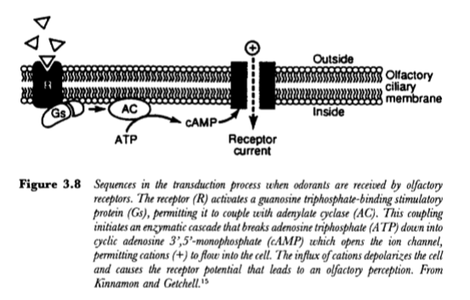
Action potentials. Olfactory receptor cells are small and have a membrane potential of about -55 mV. Receptor currents, created by sodium ion influx, flow passively to the axon hillock, where they activate Na+ and K+ ion channels to initiate an action potential. Axons of receptor cells are small (0.2 vm) and unmyelinated, and are unusually impoverished of Na+ channels (3/ pm*), all of which conspires to limit their conduction velocity to about 0.17 m/sec, among the slowest in the human body. Consequently, it requires more than 30msec for the signal to traverse the 6mm distance from the receptor epithelium to its first central synapse in the olfactory bulb. Once there, receptor cell axons converge on the mitral and tufted cells and on short-axon periglomerular cells of the glomeruli (Cf: Olfactory Anatomy above). The degree of convergence - and hence potential amplification - is extraordinary: 15 000 primary axons impinge on a single mitral cell. The main neurotransmitter that mediates this interaction is glutamate, whose primary effects are probably modulated by carnosine (a dipeptide: Beta-alanyl-L- histidine)

COLOUR
Colour is an important quality attribute in food although they do not necessarily influence their nutritional, flavour or functional quality. Consumer preferences are strongly influenced by the colour of the food. Colour is defined as the characteristic of light that is measured in terms of intensity and wavelength. Why is colour an important characteristic of food? What are its functions? How can we measure colour in foods? These are a few aspects covered in this section. We begin by first understanding the functions of colour in foods.
Functions of Colour in Foods
Different functions of colour in details, which are enumerated herewith:
1. The maturity of many fruits and vegetables is closely associated with colour development or changes in colour. Colour is also indicative of the freshness of the product. Changes in colour take place on storage that may lead to reduced or increased consumer acceptance e.g. in tomatoes- green- yellow- red. So colour acts as a ripening index in fruits and vegetables.
2. Composition Aspects- Colour indicates the composition of the food. For example, in egg yolk, the intensity of yellow colour tells us about the pigment content.
3. Grades are assigned to the food products on the basis of their colour. For example, tomatoes are graded according to their size and colour. Different prices are allocated for different grades. This is important for canning industry where they assign different grades to the canned tomatoes.
4. The end point determination during food processing is also done on the basis of the colour of the final product. For example, golden brown colour of the fried products.
5. Distinct colours are associated with different flavours e.g. pink colour to strawberry flavour, yellow to mango flavour and orange to orange flavour etc.
6. It has been seen that the flavour scores of an inferior grade (poor quality) juice can be improved by colouring it to resemble the juice of better quality. So colour serves as a standard of good quality. Also, the flavour identification becomes difficult if the products are coloured deceptively. For example, green colour for an orange juice. Also people describe white wine as less sweet in taste in comparison to the red wine even though the sugar concentration has been kept constant. Example, orange juice which had a yellow colour has been found to be less acceptable in comparison to bright orange colour juice.
Well then, colour, as is evident from the discussion above plays a crucial role in food acceptability. It contributes immeasurably to ones aesthetic appreciation for food in addition to being associated with other attributes. A number of instruments are used for colour measurements.
Measurement of Colour in Foods
A number of instruments are used for colour measurements in food. These are highlighted herewith:
a) A simple method is to match the colour of a food with coloured chips or glass and give them name accordingly.
b) Disc Colourimetry, in which different coloured discs are spun on a stage, so that the colours merge into one colour. The test sample is placed adjacent to the spinning disc and the colours are matched.
c) Tintometers are simple instruments used to determine the colour and its depth in foods for a more reliable measurement of colour.
d) Spectrophotometers are also used to measure colour. In the case of clear and transparent solutions, spectrophotometric measurements give quantitative results. For the foods that are opaque in nature, “reflectance spectrophotometry” is used. In the Reflectance Spectrophotometery, colour is measured in terms of amount of light reflected from the surface of the object at each wavelength in the range of 380-700 nm.
e) Tri – Stimulus Colourimetry, in which the colour is specified by three attributes - dominant wavelength, brightness and purity- hence referred to as tristimulus system. These three refer to the actual colour, luminosity and strength of the colour respectively.
Other than the measurement of colour, analysis of colour in food is also important. You may recall reading about the three different classes of colours – natural, synthetic and natural identical, earlier. How can we analyse or check whether the colour present in food, particularly the synthetic one, is permitted or not? There are different ways of colour analysis. The next sub-section throws light on this analysis.
Qualitative and Quantitative Analysis of Colour
Primarily, two types of analysis are carried out for food colours - qualitative and quantitative.
The qualitative analysis is carried out to check whether the dye present in food as a colourant is permitted or not. This is done with the help of various separation techniques Gas Liquid Chromatography (GLC), Thin Layer Chromatography (TLC), paper chromatography and spectrophotometry.
The colour from the food product is extracted and subjected to one of these techniques for identification of colour. In case of paper chromatography and TLC, reference values of the extracted colours is compared with that of standard and in case of GLC, retention time values are compared. Retention time is the time taken by the component to elute from the column.
Quantitative analysis, on the other hand, is done to check whether the amount present is within the prescribed limits or not. In case of GLC area of the peak obtained is directly proportional to the amount of the component present. In case of TLC the spotted portion is scrapped from the plate and dissolved in a suitable solvent filtered and the colour intensity is measured using spectrophotometer. If the artificial colours used are preset beyond the prescribed limit they might prove to be toxic to the human health. All these determinations are done for synthetic colours only.
With qualitative and quantitative analysis of colours in foods, we come to an end of our study on the properties of foods.

